周边纪念品

首页内容：

标题：
The Physical Form of Inspiration

简介：
Brand Memorabilia—The Physical Form of Inspiration—is a tangible extension of brand culture. It translates abstract concepts, visual identity, and emotional value into everyday objects that can be touched and used, serving as an emotional bridge between the brand and its audience beyond functional purposes.

图片：
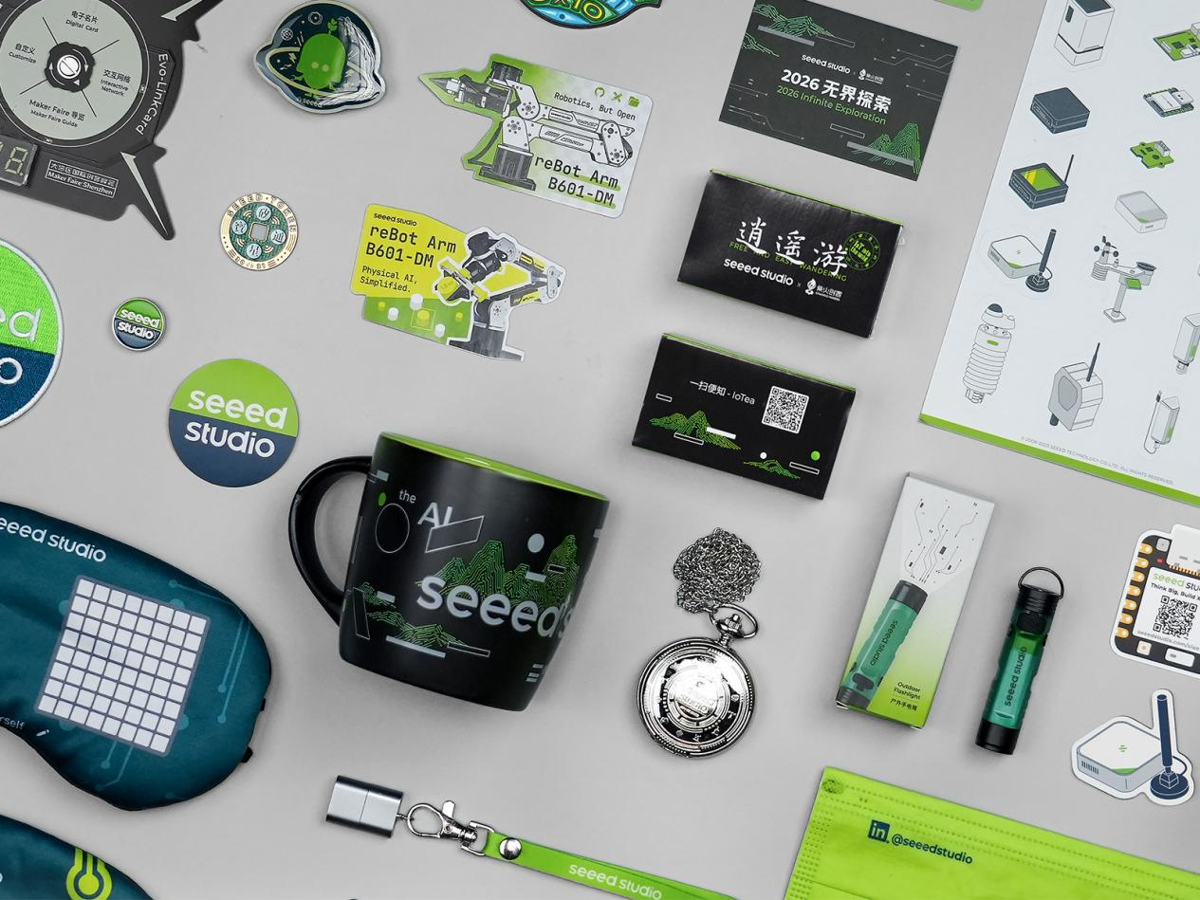

内部页面:

The Physical Form of Inspiration
Brand Memorabilia — The Physical Form of Inspiration — is a tangible extension of brand culture and a supplementary expression of brand narrative.
It currently encompasses two directions:
- Everyday Aesthetics — focusing on tactile quality and daily usability, with brand visual cues woven naturally into real-life settings.
- Annual Gift Collection — focusing on scenario-based experiences and the ritual of gift-giving, conveying the brand's understanding of specific use cases through thoughtful curation and packaging design.
Brand memorabilia carries no narrative pressure from the main product line, nor does it pursue excessive expression. They exist quietly in the interstices of daily life—with measured design interventions, they complete a light, effortless dialogue between the brand and its people.
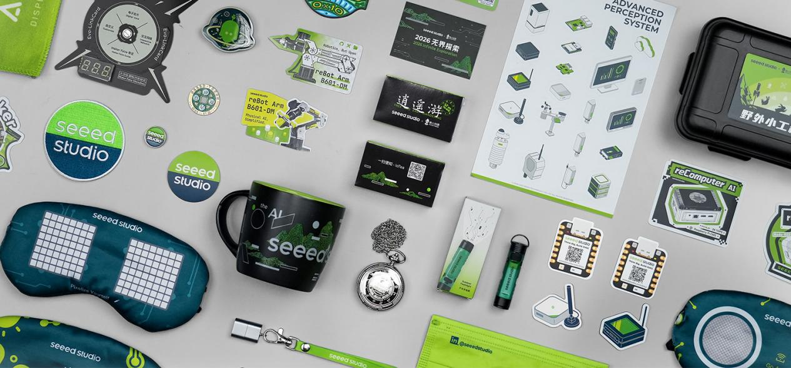

Everyday Aesthetics
The memorabilia closest to us are often the least conspicuous. They don’t mind the occasion, need no explanation, and ask for no attention. They simply settle into the corners of daily life—on collars, in backpack pockets, on fridge doors, within arm’s reach on a desk.
Yet in this quiet companionship, the brand achieves its most profound connection: not to be seen, but to be owned; not to be remembered, but to be used.
This is the unique power of portable objects—turning the brand from something you see into something that stays with you.
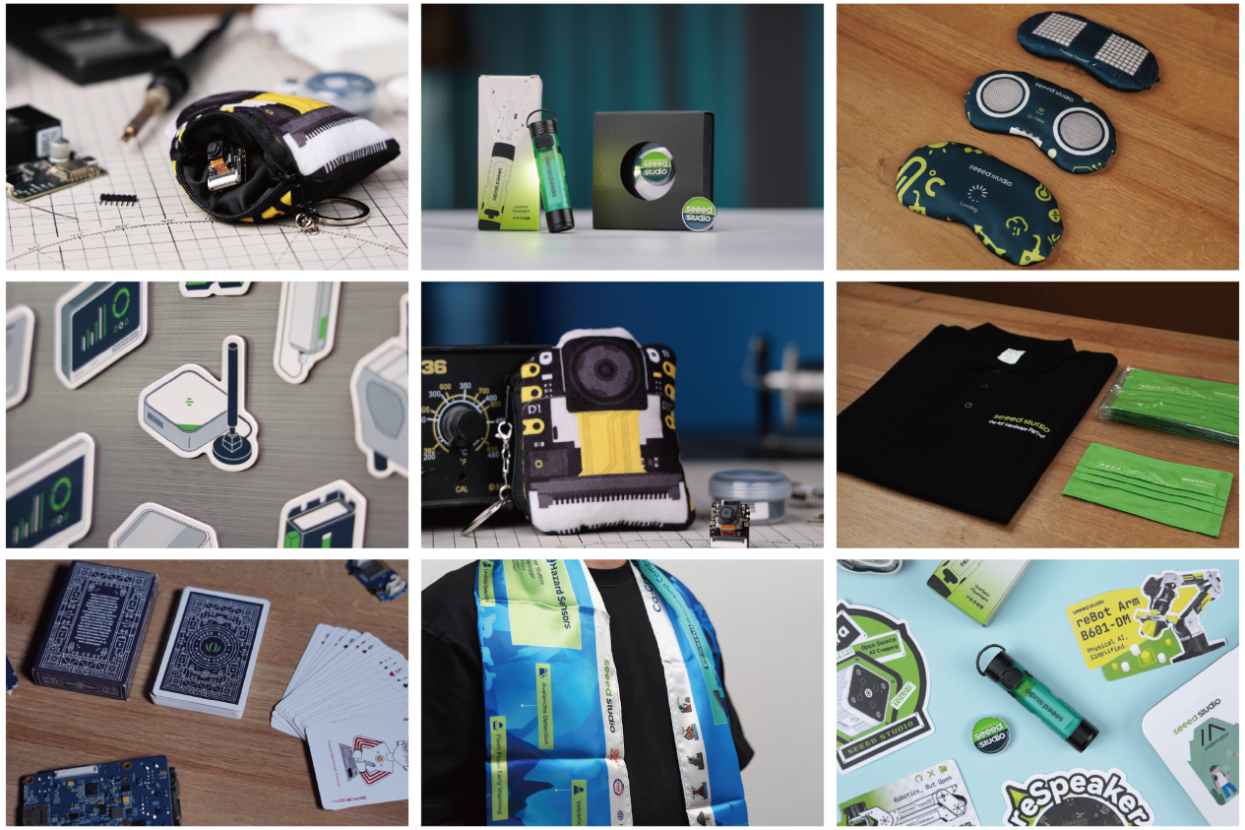

Annual Gift Collection
One box a year. Different every year.
It took five years to realize that each box is a time capsule—not of products, but of where the company stood and what we wanted to say to our recipients that year.
Lined up together, the five boxes show little consistency. Paper, fabric, steel, tea leaves, circuit boards—materials shift, directions turn, every year is different. And that very difference is the true hallmark of this series. We never followed a fixed template; instead, we asked ourselves anew each year: What did we do this year? What do we want to say? What best represents us right now?
The answers were never the same.
2022 · Riding the Waves New Year Box
Filled with objects to post, flip, and tear off—echoing that year's rhythm: turning the page. Each flip, a small farewell and a new beginning.
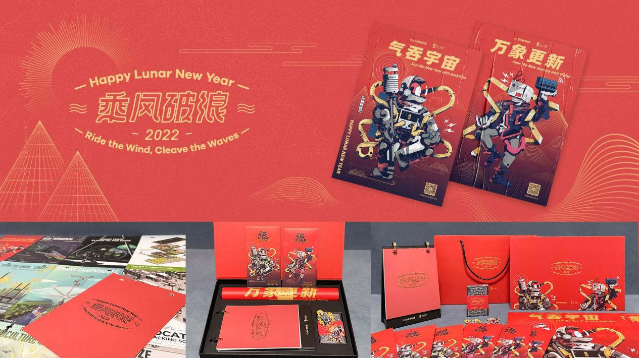

2023 · On‑the‑Go Nap Care Package
From paper to fabric—a complete napping set. Amid the busyness, a moment to close your eyes in peace.
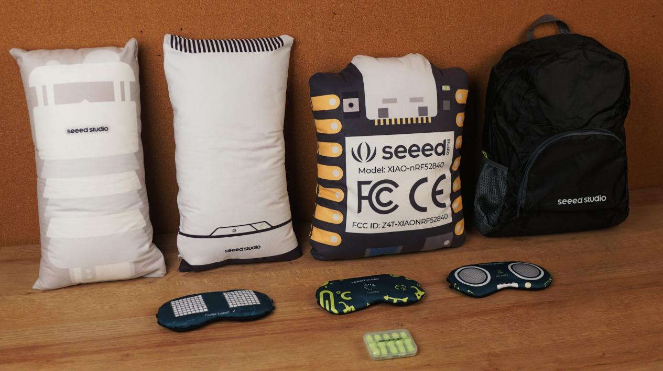

2024 · Field Mini Toolkit
That year, our gaze turned outdoors. Each item hints at "heading out." What we wanted to say: Let's go outside.
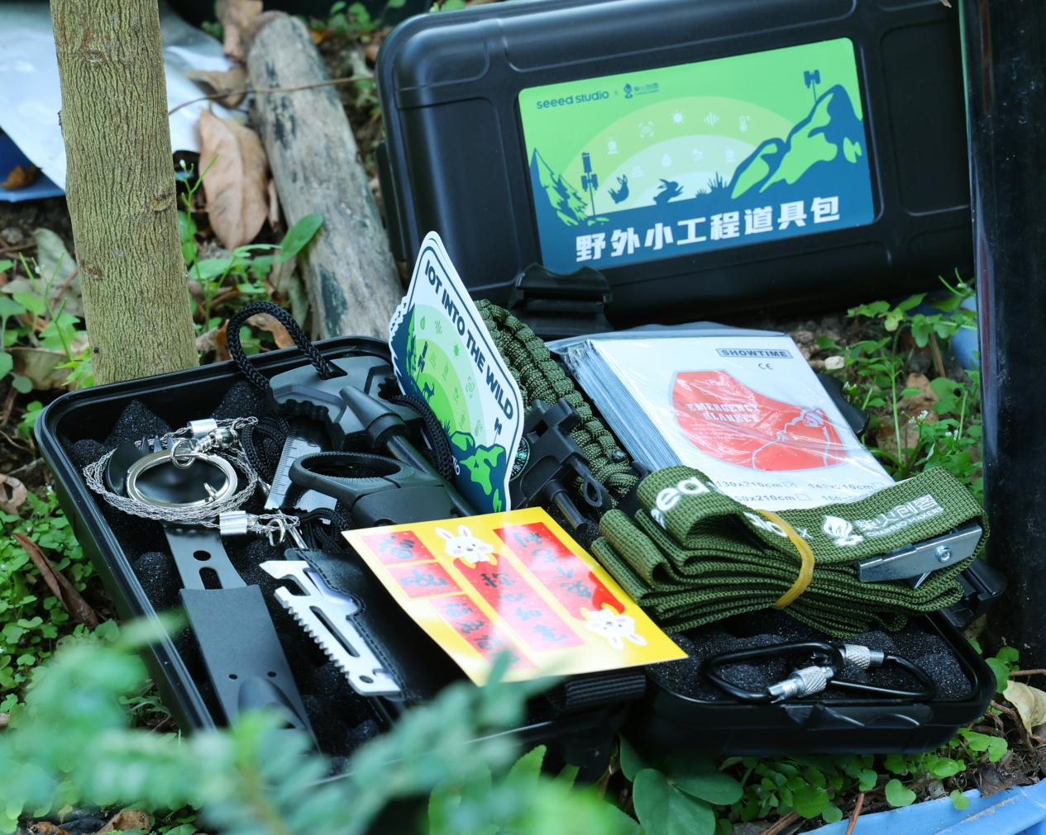

2025 · Xinuo · IoTea
No matter how far you roam, come back for a cup of tea. IoT meets the tea garden—a box that releases the scent of the hills when opened.
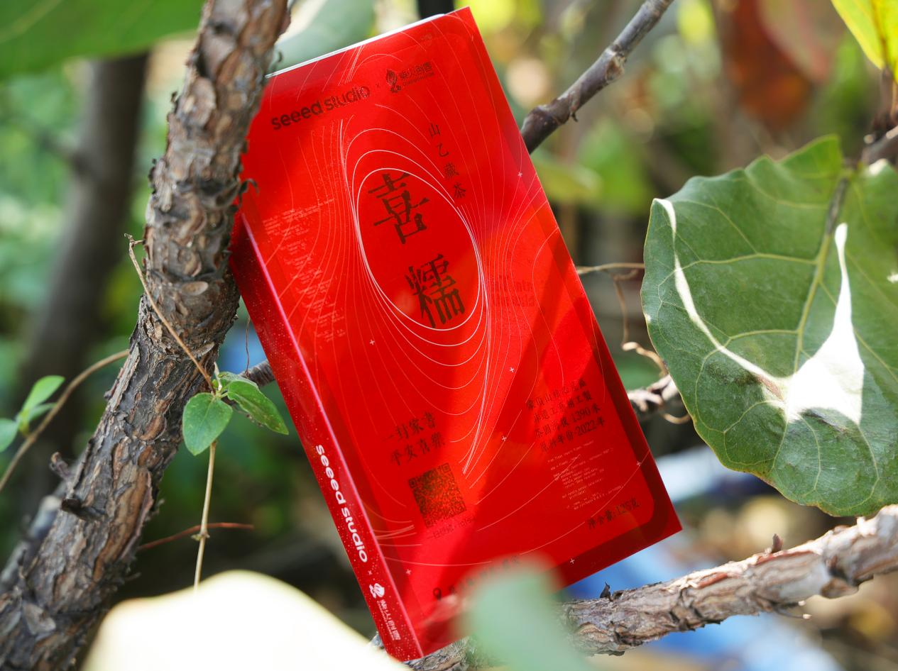
2026 · Mega Evolution
Year five. The Mega Evolution box—three layers, opened one by one. Ritual, practicality, and tech, all inside. It marks a milestone and a dash forward, pointing the way ahead.
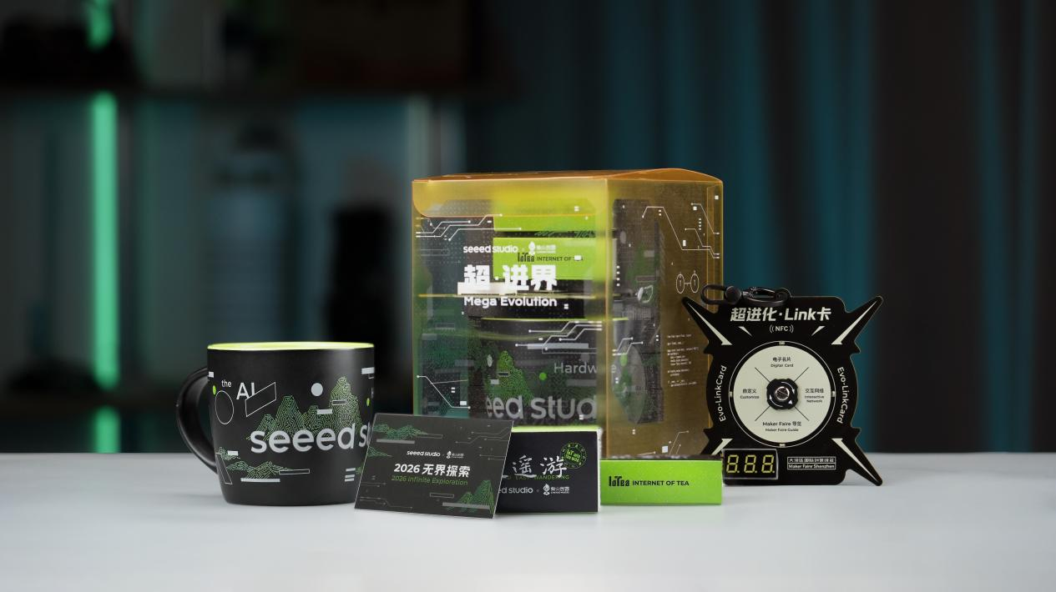

Five years on, the contents have changed endlessly, but the reason never has:
At the end of every year, we offer a tangible token of gratitude, on behalf of the brand, to everyone who has walked alongside us—
Thank you. See you next year.

Deconstruction Special: Mega Evolution
Mega Evolution is a gift about crossing boundaries—between the physical and the digital.
The shell is transparent, revealing its structure at a glance: tea on the top layer, a link card in the middle, and a cup at the bottom. Like an exploded view of a product, opening is deconstruction, and deconstruction is reading.
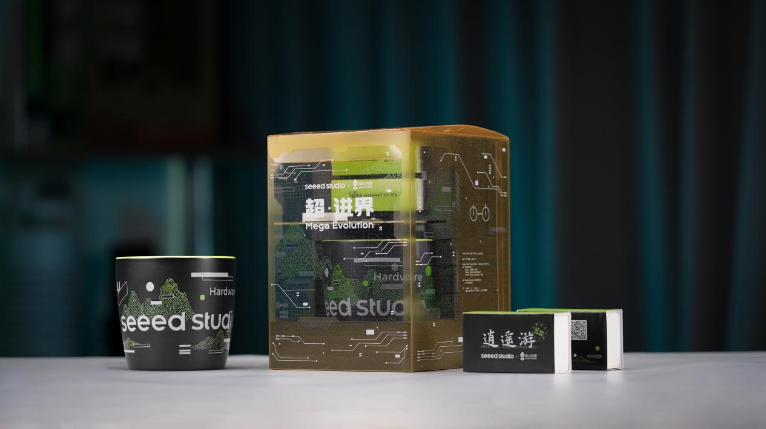
The lines on the packaging draw from two sources: the human symbols on the 1977 Voyager Golden Record, and the circuit traces of a PCB. One points to the cosmos, the other to the digital world. The green patterns transform circuit traces into the shapes of mountains and water—where cold industrial structure meets Eastern natural imagery, and PCB coexists with tea in a single box.
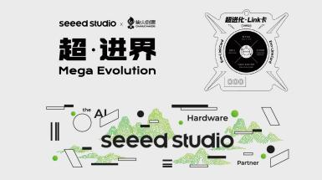 | 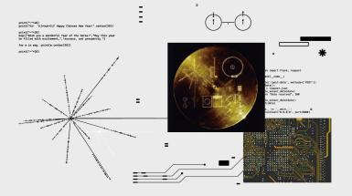 | 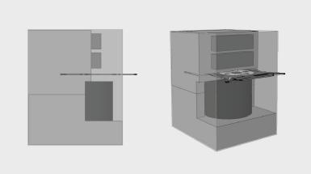
Each of the three layers has its role: tea offers taste, the link card enables connection, and the cup provides a vessel.
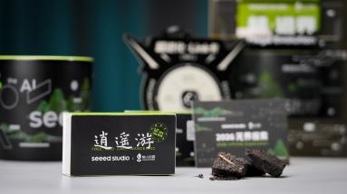 | 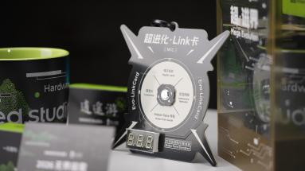 | 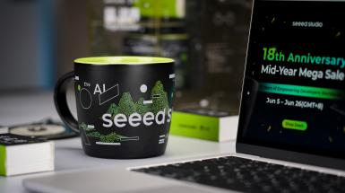
Setting out from the physical world, journeying through the digital, and returning to the physical—a complete crossing, all contained in one box.

These are our attempts over the years to turn inspiration into reality. Thank you for reading this far.

4，视频合集（宏基）
主图：

标题：
产品影像辑
Product Showreel

详情：
This is more than a simple montage—it is a complete visual reconstruction driven by the core DNA of each product.
We deconstruct our product lines to endow each with its own cinematic life. By integrating distinct rhythmic soundscapes, customized color grading, and multidimensional editing frameworks, we ensure every device possesses a unique "visual fingerprint."
Through penetrating cinematography and striking live demos, we strip away all visual noise to zero in on core functionalities. Driven by a razor-sharp editing tempo, we deliver a seamless transformation from abstract technical concepts to an ultimate sensory experience.
https://www.youtube.com/watch?v=vEc32BaR9ZM
https://www.youtube.com/watch?v=_S-Mewc56KE
https://www.youtube.com/watch?v=oubHMeJ379g
https://www.youtube.com/watch?v=ny22Z0cAIqE
https://www.youtube.com/watch?v=lUu6zLt30os
https://www.youtube.com/watch?v=8OQevtNNLUA&t
https://www.youtube.com/watch?v=GYtKNI3h7RI
https://www.youtube.com/watch?v=XFHGS82S3fA
https://www.youtube.com/watch?v=ONbpv3seiG8&t
https://www.youtube.com/watch?v=Xjc4AAqztFM

5，交互标牌（阿远）
主图：
标题：

当易拉罐有了 “AI 灵感”
详情：

从色彩识别到梦境生图的智能交互体验
这不仅仅是一个标牌，更是一台会读懂你情绪的饮料推荐机。通过实时识别色彩，捕捉你的穿搭，并在秒级时间内生成专属 City Pop 海报，带你进入特调梦境。
🖼️ [图片 1：交互标牌系统主视觉 (Banner) ]

灵感起源：打破次元壁的未来交互标牌
传统的标牌往往只承担静态的信息展示，而我们希望打造一个 “活” 的、能与人产生情感共鸣的智能装置。
我们的饮料推荐机在物理硬件结构上由以下核心组件精密集成：
- 定制易拉罐造型外壳：作为整个交互标牌的品牌主视觉载体与物理容器，将所有电子元器件与发光灯带完美包裹，形成统一且极具辨识度的商业展示终端。
- reServer 边缘计算主机：搭载高性能边缘处理器，负责运行 Node.js 串口服务器与交互 Web 应用，进行本地图形渲染与多模态 AI（Gemini API）网络请求交互。
- 交互大屏与高清摄像头：大屏用于展示充满 City Pop 动效的交互 UI，高清摄像头用于实时捕捉用户肖像，提供直观的人机交互界面。
- Seeed Studio XIAO ESP32C3 主控板：作为底层的执行大脑，负责接收来自 reServer 的串口指令并渲染高精度的 LED 动态灯效。
- 专属定制载板 (Carrier Board)：为 XIAO ESP32C3 提供专用的扩展接口，集成了电平转换电路（将 MCU 的 3.3V GPIO 逻辑电平转换为灯条所需的 5V 控制电平）与独立的供电稳压模块，保障大功率灯带连续工作的安全与稳定性。
- 内置智能可寻址灯条：卡入易拉罐外壳的结构凹槽中，通过光影流转直接将用户的虚拟梦境投射到物理世界。
🖼️ [图片 2：用户在易拉罐交互机前的互动场景]

虚实同步的四大交互流程
整个交互标牌系统通过软件、AI 与硬件的协同，实现了闭环的数实交互：
- 影像基准录入 (Calibration)：系统对主打色彩与视觉风格进行预先录入，确立色彩空间。
- 交互镜头捕捉 (Scanning)：用户站在易拉罐标牌前，摄像头捕捉用户肖像，AI 提取用户衣着的主导色与情绪气场。
- AIGC 梦境海报生成 (AIGC Generation)：Gemini 智能体读取用户脸型、发型、表情及着装，将其重构为 City Pop 风格的 2D 动漫形象，融于专属背景中。
- 巨型易拉罐光影同步 (Hardware Syncing)：匹配结果生成的瞬间，后台通过串口通信向易拉罐内的 ESP32 主控板发送信号，内置在易拉罐外壳上的智能灯条立刻亮起对应的流星动画效果，实现物理空间与数字画面的瞬间同频。

10 大情感色彩与梦境主题
标牌根据识别到的不同颜色，将用户引导至 10 个不同的情绪空间。虽然代表了不同的推荐茶饮意象，但其核心是用色彩和画面进行情感链接：
- 黑色 (Black)・午夜镜廊
- 白色 (White)・白色自动洗衣店
- 红色 (Red)・红丝绒剧场
- 蓝色 (Blue)・深海电话亭
- 绿色 (Green)・发光植物温室
- 黄色 (Yellow)・落日轮滑场
- 紫色 (Purple)・占卜隧道
- 粉色 (Pink)・棉花糖浴室
- 橙色 (Orange)・橙味便利店
- 灰色 (Grey)・灰调失眠电台
🖼️ [图片 3：10 色灯光与梦境海报对应展示]

软硬件协同背后的技术实现
我们设计了极具稳定性和扩展性的技术架构，着重展示了边缘计算（IoT 硬件）与云端大模型的数实协同：

1. 核心芯片与定制载板协同 (Seeed Studio XIAO ESP32C3 & Carrier Board)
物理控制的核心是 Seeed Studio XIAO ESP32C3 微控制器与我们设计的专属定制载板。XIAO 主控板基于 RISC-V 32 位单核处理器，性能强劲且功耗极低。由于 WS2812B 灯条需要 5V 逻辑电平以保证信号稳定传输，我们在载板（Carrier Board）上集成了专用的高速双向电平转换芯片，将 XIAO 芯片 3.3V 的 GPIO 逻辑电平平滑转换为灯条所需的 5V 信号电平，并配合电容滤波与独立稳压模块，彻底消除了由于灯条亮度剧烈变化引起的电源纹波干扰。

2. 边缘服务器 reServer 与物理串口传输
作为交互标牌的 “大脑”，reServer 边缘主机通过 USB 数据线直接连接到定制载板的 USB 接口。数据通信建立在标准串口协议（波特率 115200）物理通道之上。在 reServer 上运行 of Node.js 串口中转网关负责将云端 AI 识别出来的色彩气场转换成极轻量的 ASCII 格式数据帧（如 'R,G,B\n'），通过 USB 物理串口直接写入 XIAO ESP32C3 芯片，实现了几无延迟的跨平台数实同步。

3. 毫秒级非阻塞灯效状态机
XIAO ESP32C3 芯片内部运行基于 C++ 编写的无阻塞式固件。它固化在芯片中，使用系统内置的 millis () 定时器执行轮询计算，摒弃了会挂起 CPU 的 delay () 延时。这使得主控板在高速渲染 “彗星拖尾（Comet）” 与 “彩虹跑马灯” 算法时，仍能以微秒级的速度扫描串口输入缓冲区，确保在屏幕端 AIGC 画布切换的同时，实体易拉罐灯条能够瞬间平滑变色。

4. 多模态 AI 与生成式海报
系统调用 Gemini 多模态接口，一条通道进行视觉色彩识别，另一条通道根据定制化 Style Prompt，快速输出无文本水印的 3:4 比例复古 Cel 动画风格海报，完美契合交互标牌的高清大屏呈现。

5. 智能软硬件集成架构
整个交互标牌系统通过将 reServer 边缘计算、XIAO ESP32C3 底层控制、高电流控制载板、以及定制的易拉罐造型外壳一体化集成，构建了一个兼顾软件美学、AI 多模态智能与坚固硬件工程性的完备标牌装置，极具大赛竞争力和商业应用前景。

赋能未来潮流零售标牌
“标牌即媒介，互动即情感” 通过将冰冷的物理易拉罐外壳转化为能感知人类色彩、能用光影与 AIGC 进行即时反馈的智能终端，我们不仅提升了品牌形象的趣味度，更展示了未来智能新零售标牌的无限潜力。这种能够引发自发性拍照、社交分享的交互装置，无疑是线下实体店面引流的制胜法宝。

